Home Assignment _Langchain Memory
1.Unzip the file
2.Import into VS code
3.update the Mongo Db credentials,groq API key,Mistral API key in .env file
4.npm install
5.npm run dev
6.Import the postman collection and check the conversation memory
Open Postman. File on the left corner.Click on Import.Select the file ‘QA Bot TS - LangChain API Copy.postman_collection’ from the below path
E:\Vidhya_Assignment link\Sep 12th\Home Assignment
Start New Conversation
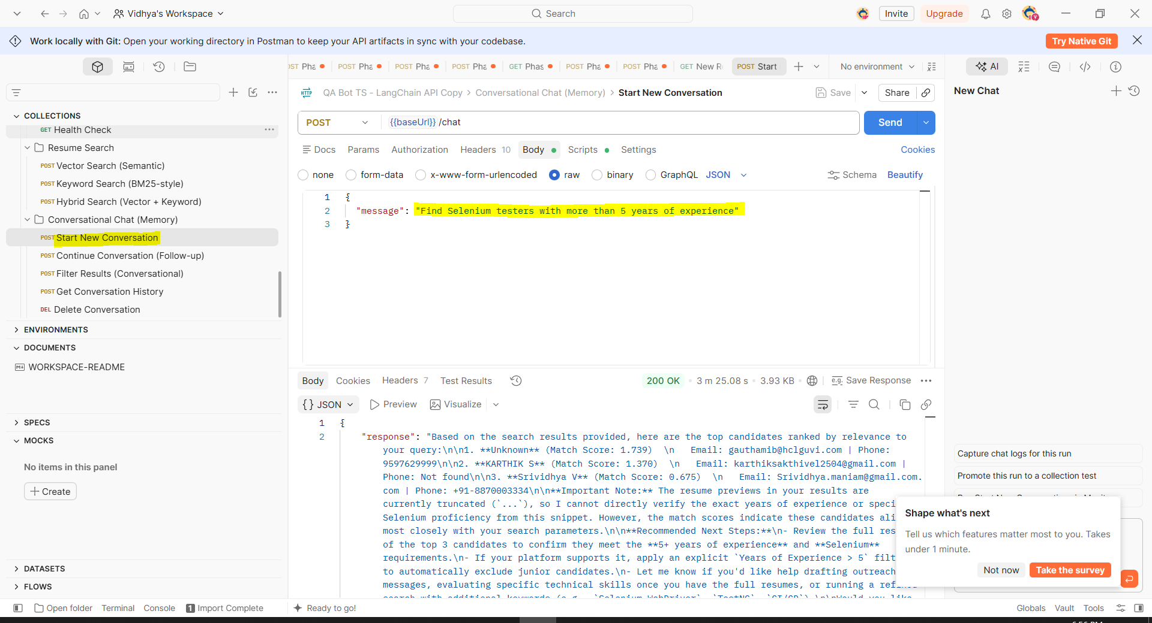
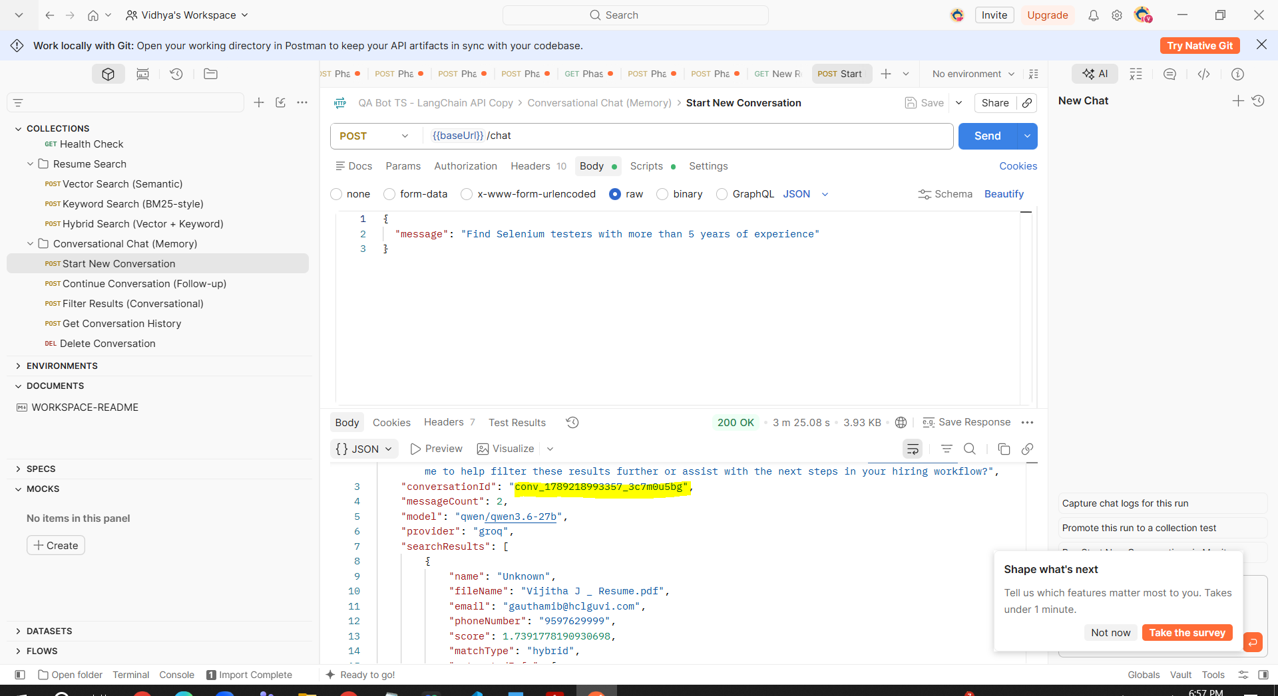
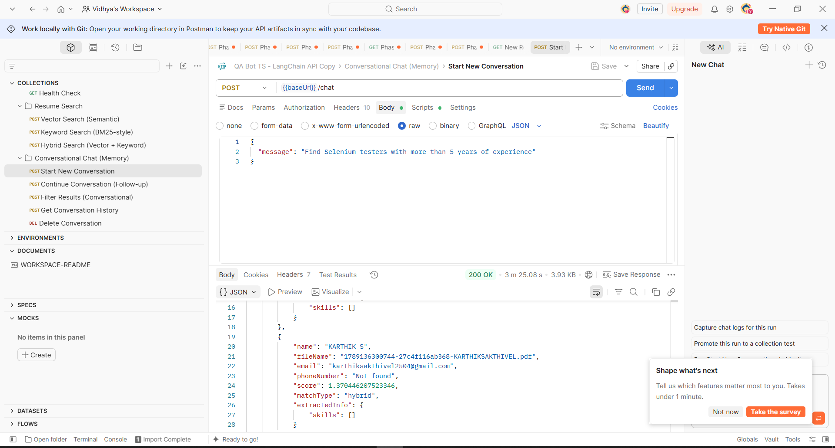
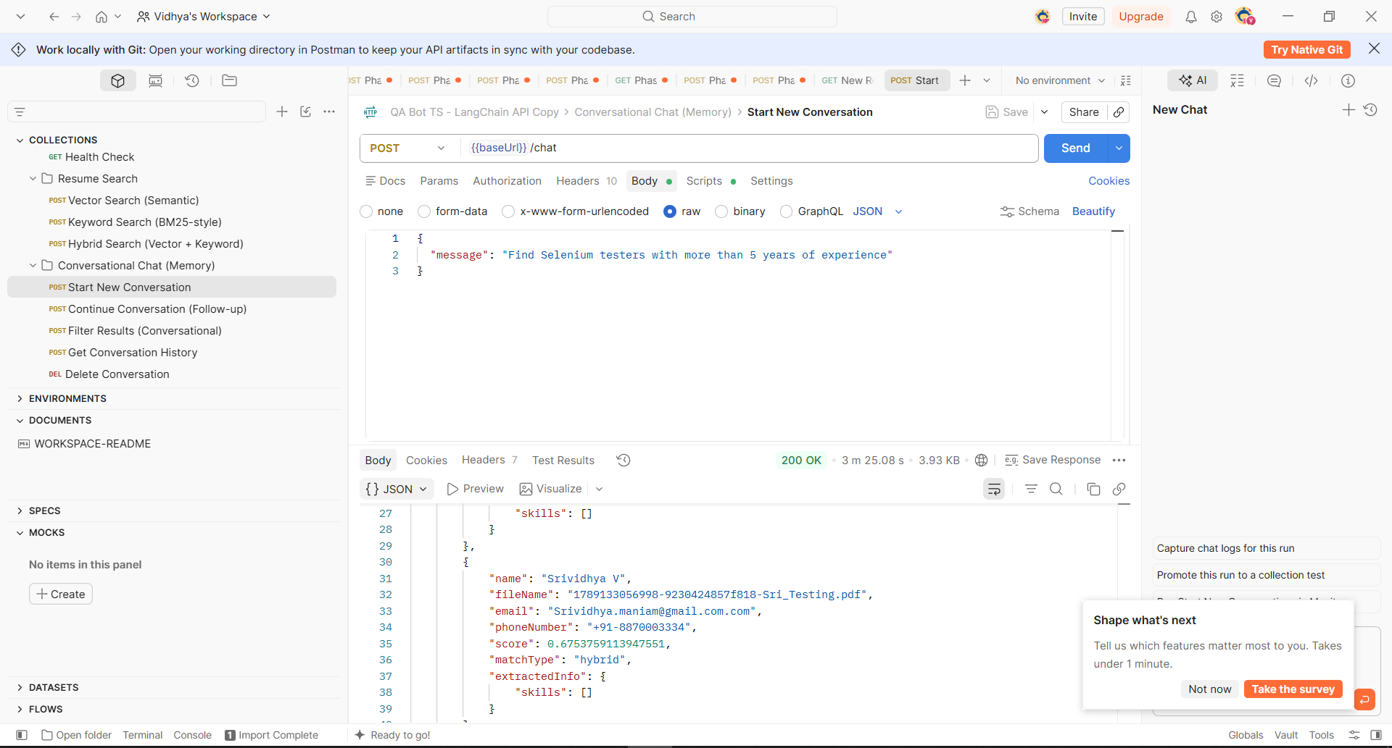
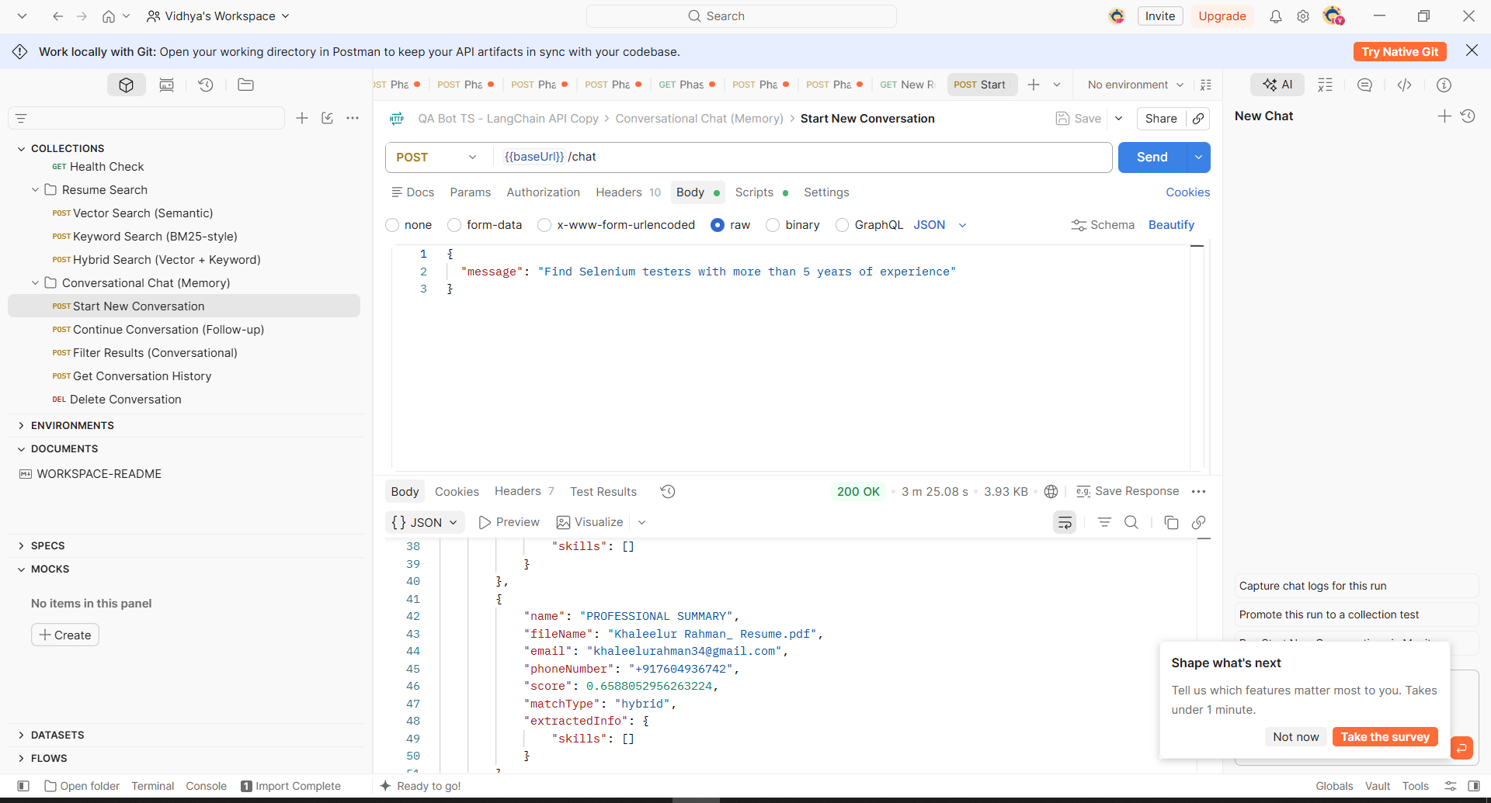
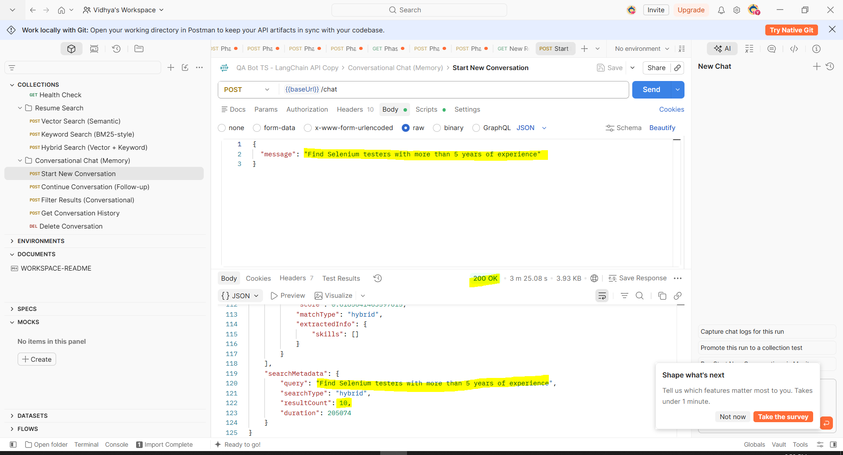
Continue Conversation (Follow-up) :
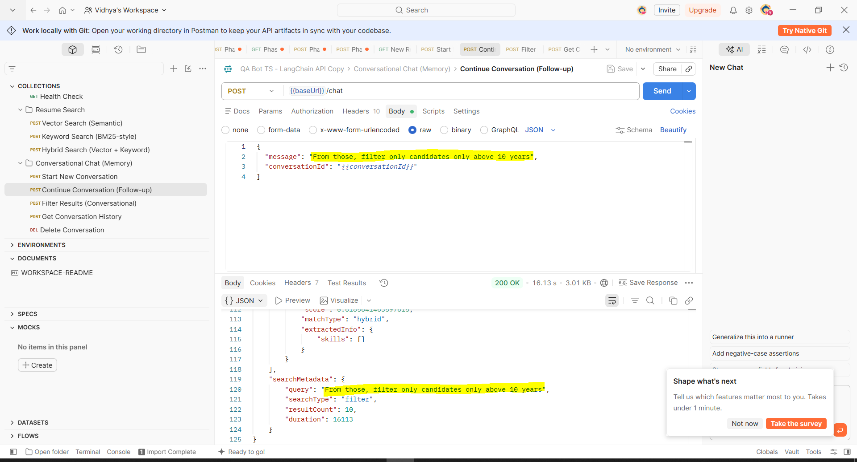
Final Result(Conversational) :
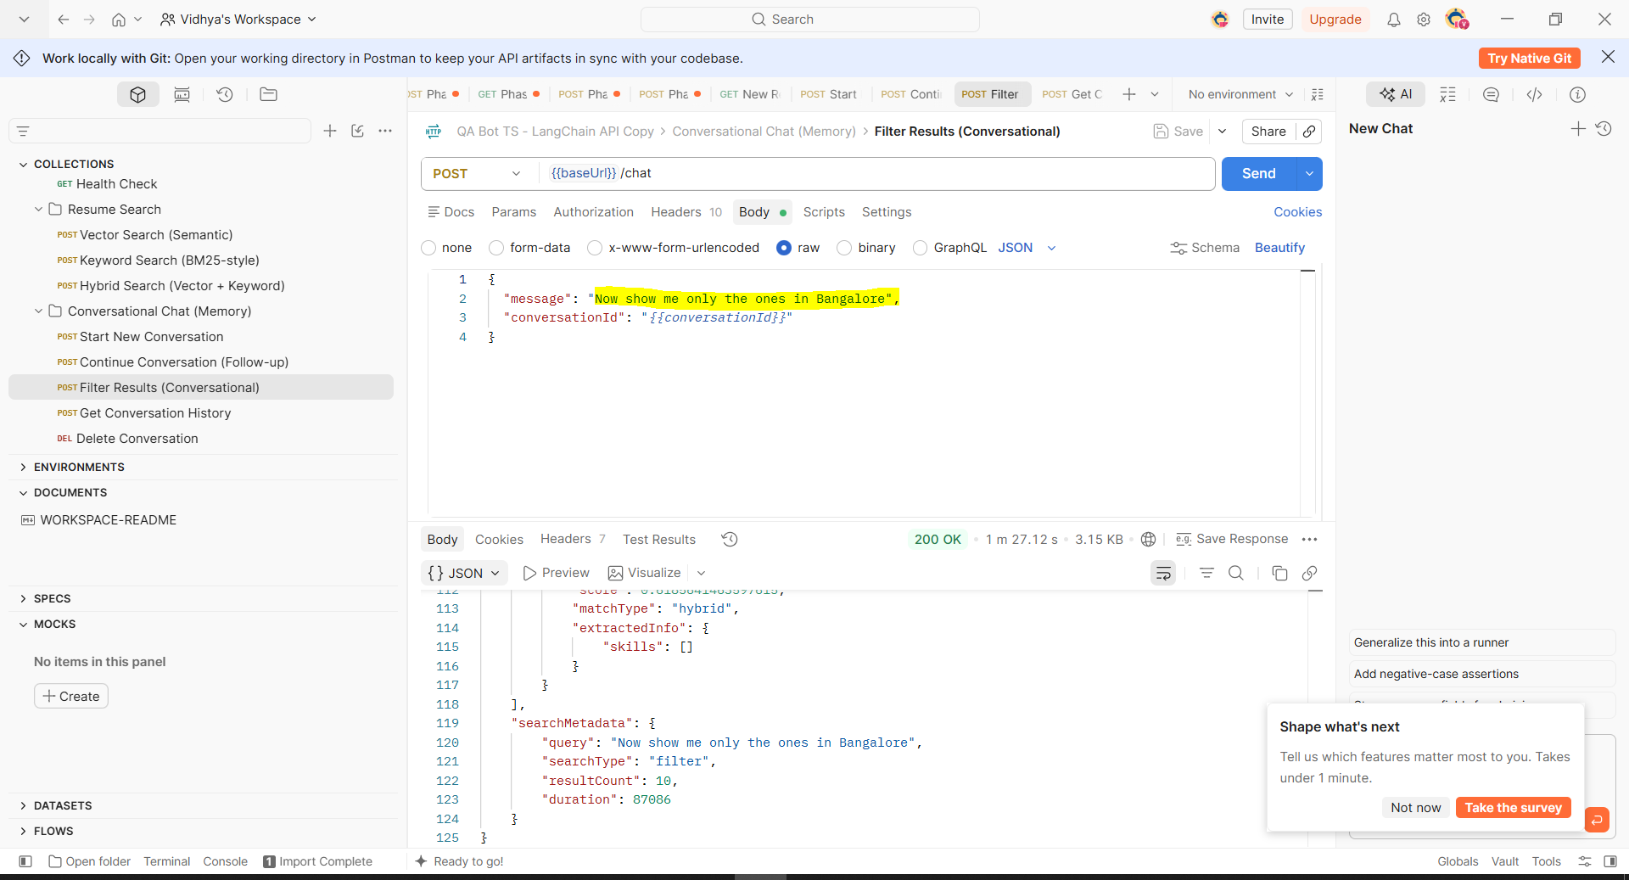
Get Conversation History :
